CommandShell Extender
- CommandShell Extender
  - Application
  - Features

Application

Execution of Windows or third-party software commands with specification of parameters when working with Task Planner.

Features

To execute any command with this extender, you have to use the Task Planner. Select the following main menu item: Service\Task Planner…. The Task Planner window will appear. Create a task and add a step to it, named Execution of commands. Running applications.
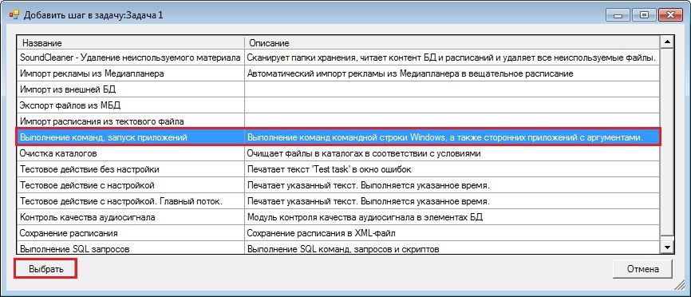
A window with step settings will appear.

Here you can specify the following parameters:
- Arguments — a list of arguments sent to a command, application or a script.
- Command or executable file — a Windows command or an executable application file, as well as .bat and .cmd executable scripts.
- Standby — selection of standby mode for application closedown:
  - Do not wait — do not wait for the processes to be finished after execution.
  - Wait indefinitely — wait for the processes to be finished for an unlimited period of time, until they are finally finished.
  - Wait for N seconds — wait for the processes to be finished during N seconds and then terminate them.
- Current directory — the directory which is the subject of the command, application or script.

