MdbHistoryViewer Extender
Supported starting from versions 2.15.37.261 and 2.15.361

Application
MdbHistoryViewer Extender is designed for viewing the media item editing log history (additions and deletions). The extender adds a new option to context menu of remote MDB items window.
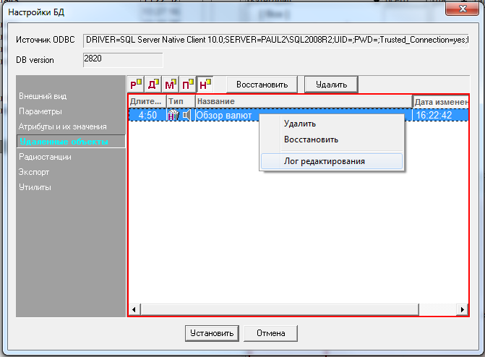
Selecting the Editing Log menu option will open the history window for selected item.
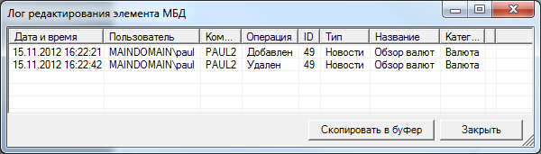
The history will only be available if MS SQL database has been updated with the help of the Create_PH_HISTORY.sql script.

Configuration
To connect the extender to the software, it is enough to place specified extender library file MdbHistoryViewer.dll to Extenders subfolder of the application’s folder and then restart the application.

