PelemHyperlinks Extender
- PelemHyperlinks Extender
  - Application
  - Features

Application

PElemHyperlinks is an extender that lets you add a number of hyperlinks to media items’ properties. The extender creates “Hyperlinks” submenu in context menu of Schedule and DB, that contains the first ten hyperlinks assigned to this particular object.

Features

Для назначения гиперссылки выделите нужный элемент, в контекстном меню выберите пункт Свойства объекта. В открывшемся окне перейдите на вкладку Польз.. Нажмите кнопку Создать.
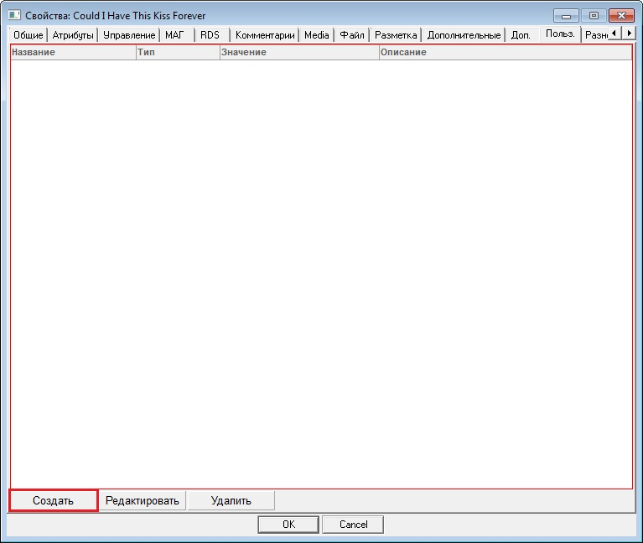
In the window that appears, fill in the following blanks:
- Name — any user name assigned to the hyperlink.
- Type — specify type of the newly added user attribute. The type must be "Hyperlink" in this case.
- Value — enter hyperlink.
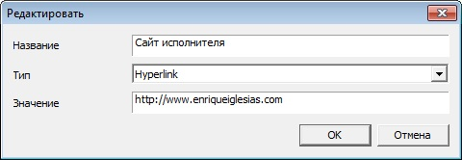
Click OK. Now, the added hyperlink will be displayed on the User tab.
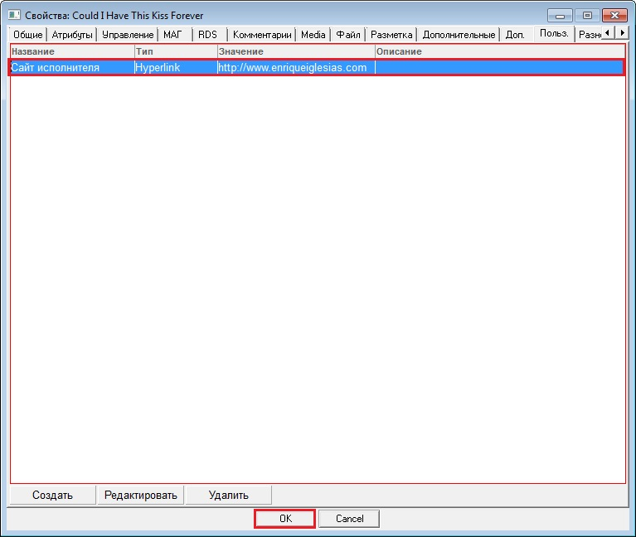
Now, if you select this item and open the context menu, the Hyperlinks submenu will be shown at the lower end. Opening this menu, you jump to the list of the first ten hyperlinks added to the object’s properties. If you select any hyperlink, the related document will open.
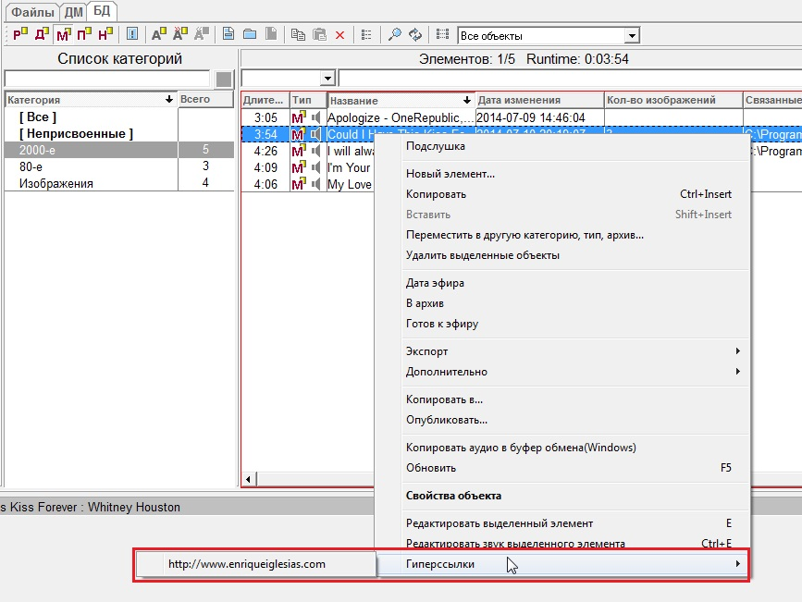
To open hyperlinks, you can use shortcuts (see Configuring shortcuts and remote control). To configure these shortcuts, select Service\Shortcuts and remote control settings from the main menu. In the Configuration of shortcuts and remote control window select the section Components.
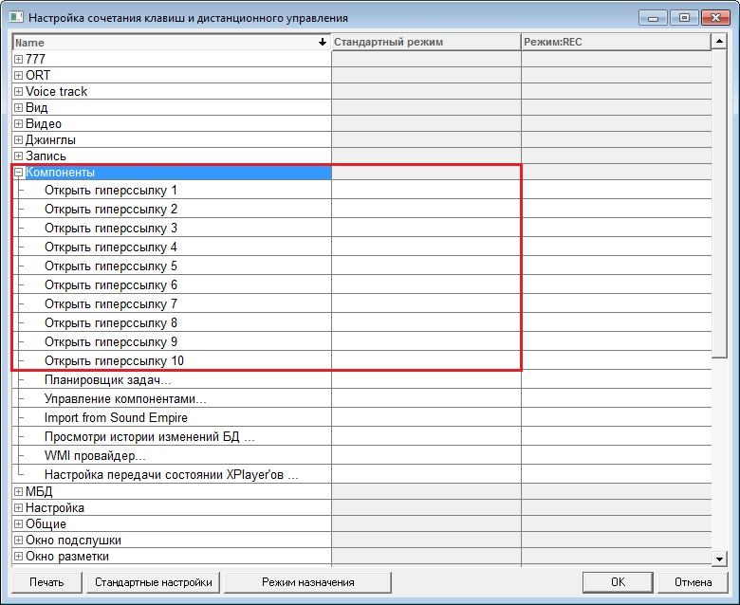
You can assign shortcuts for the first ten hyperlinks. For example, to open the first hyperlink specified in the object’s properties, select it and click on Assign mode. Now use the shortcut on your keyboard and the names of the keys you have just used will be shown in the Standard mode column.
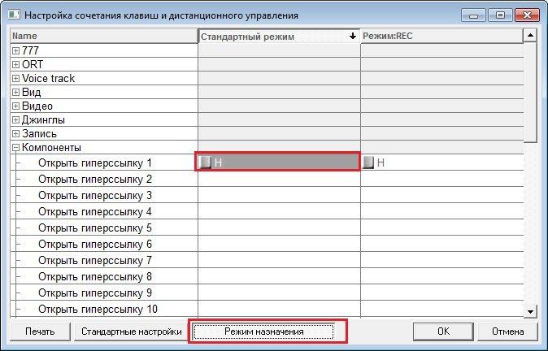
Click OK. Now, selecting an item on Schedule or DB tabs and pressing respective key(s), you will be able to open the hyperlink.
Note: You can add, change or delete shortcuts in the Edit Shortcuts window.

