ScheduleToXmlFile Extender
Available starting from v 2.15.102.88

Application
This extender saves schedule data for a specified date to an XML file.

Configuration
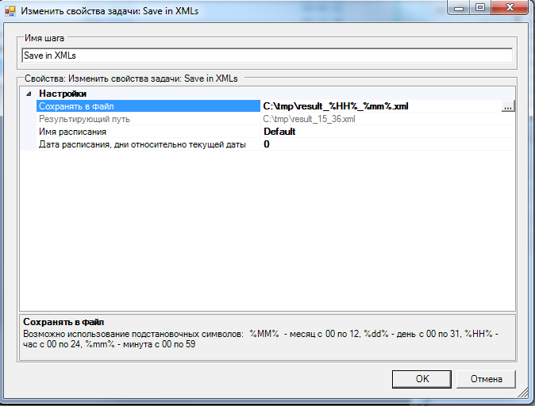
Task name – user name of the task.
Save to file – full path to the file you with to save schedule data to.
Starting from versions 2.15.102.280, 2.16.0.77 and 2.17.0.121 there is now a possibility of using replacement symbols in file and directory names, for example: %MM% - month from 00 to 12, %dd% - day from 00 to 31, %HH% - hour from 00 to 24, %mm% - minute from 00 to 59. For more details, see ticket #20489. The complete list of available replacement symbols can be found at the msdn website.
Schedule name – select schedule to be saved from the list of available schedules.
Schedule date, days from current date – specified a shift in days in relation to current date, which defines the date of saved schedule.

