MdbHistoryBrowser Extender

Application
MdbHistoryBrowser extender is designed for viewing media (DB items) editing history. Its special features include:
- Asynchronous loading of data and the use of cache
- Possibility of creating user filters applied on the SQL server side
- Grouping of multiple changes in properties and attributes related to the same media item

Operation Requirements
For correct operation of this application you need a PH_HISTORY table v 4 in DB. You can find 3 files in SQL directory:
- PH_HISTORY_Create.sql – create PH_HISTORY v 3 table and related triggers
- PH_HISTORY_Update.sql – update PH_HISTORY table to v 4. Creation of calculated fields
- PH_HISTORY_Drop.sql – delete PH_HISTORY table and related triggers

User Interface
To open the MDB History Browser component, select Components > View DB changes history... from the DJin main menu. Let’s have a closer look at the floating window that appeared.
In the upper part of the screen we can see a list that shows multiple changes, in the lower part – a preset filter.
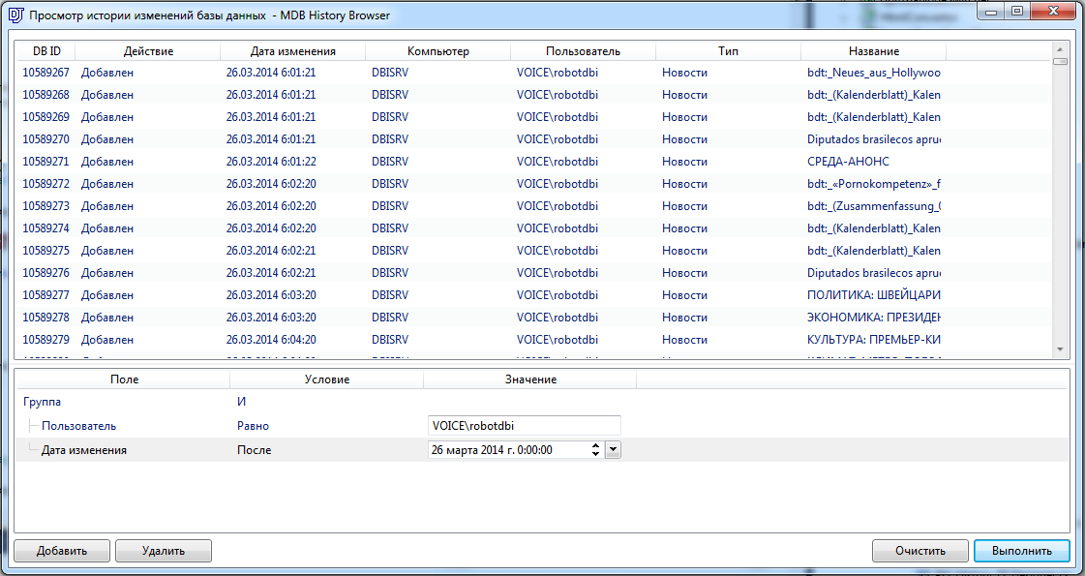
By double-clicking on any record in the list, you can open a floating window that shows a set of changes made during a single operation.
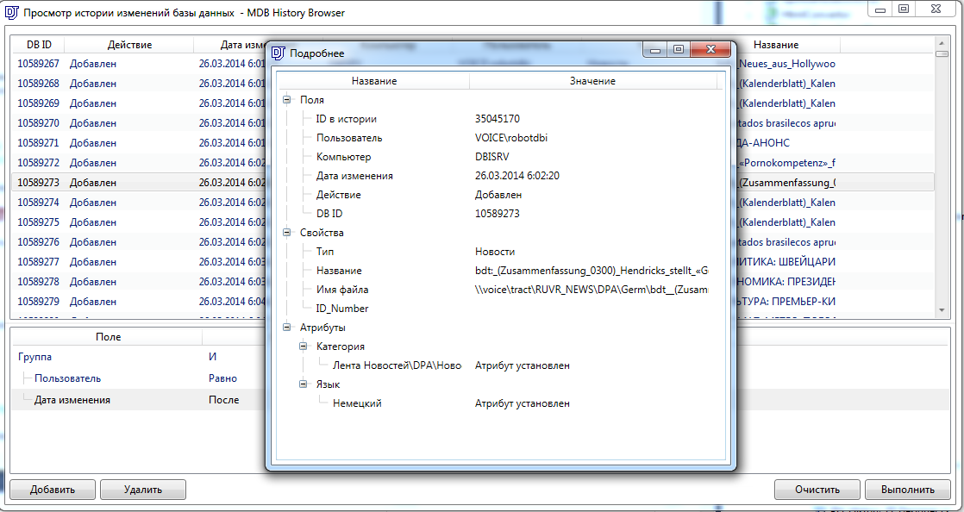
You can configure filters and their conditions via context menu. A flag in the latter indicates selected filter. If you remove the flag from a Condition, the filter will not be used in requests.
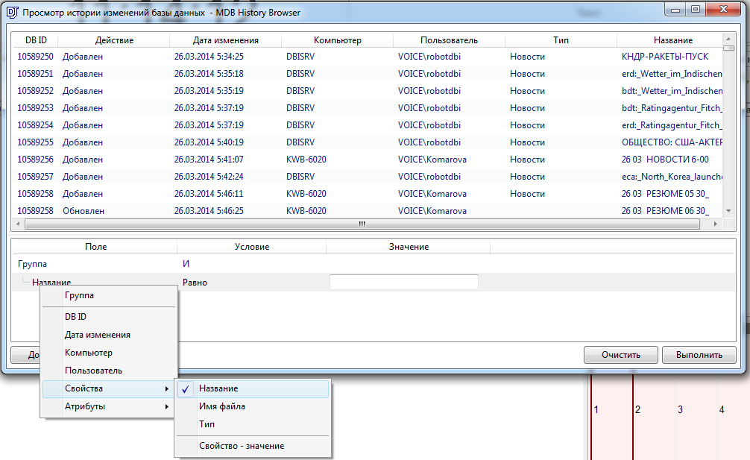

Build References
- D3API.dll
- D3APICommon.dll
- ICSharpCode.TreeView
- Microsoft.Practices.Prism.dll
- Digispot.Practices.Prism.Extender.dll
- Xceed.Wpf.Toolkit.dll
- WrapperCollection.dll
- LinqKit.dll

