SchedulerMediaAnalyser Extender

Application
SchedulerMediaAnalyser extender is designed for audio quality signal analysis with the help of the preset number of analyzers.
The extender adds Audio signal quality control option to the Task step tab. When configuring the step the user selects a category with media files (from DB), edits the list of analyzers and sets the parameters for each anazyler.
One run of the task analyzes only one item – the first in a category that was not checked earlier. After that the item is no longer checked until the audio of the item is changed, for example, after another file has been assigned to it, or it has been edited in an audio editor.
The items in a category are shuffled by modification date, from older to newer ones.
During analysis, no MDB item parameters that influence the sound are taken into account, such as audio level, rubber band and so on. Only pure contents of the file are analyzed.

Configuration
1. To configure the extender, select the following item from the main menu: Service\Task Planner…
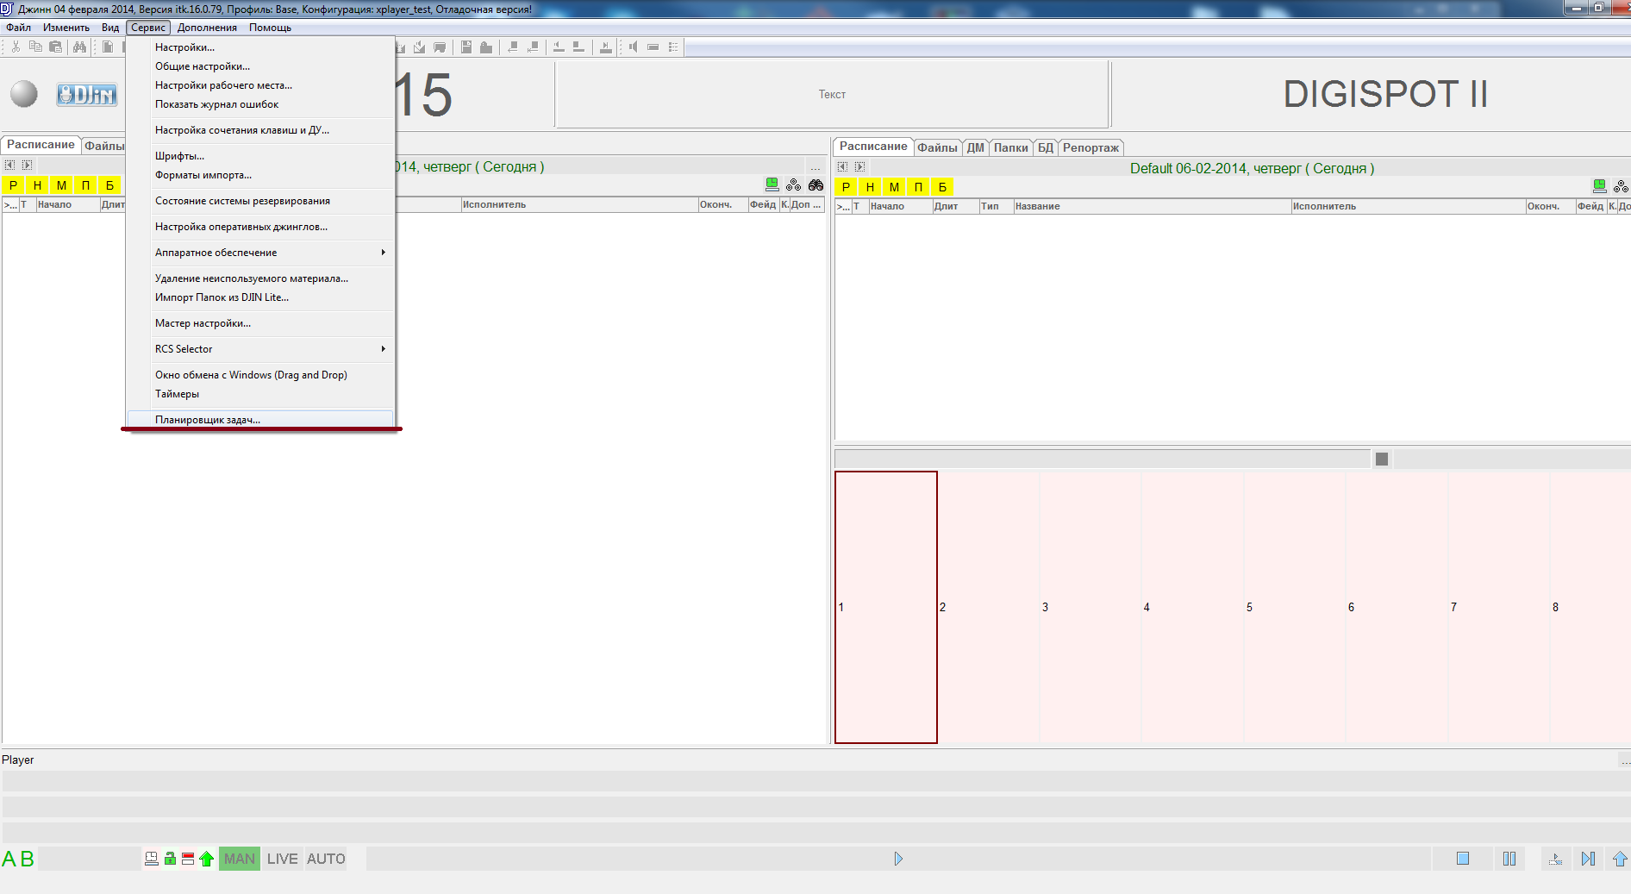
2. In the Task Planner dialog box that opens, create a new task and specify its parameters.
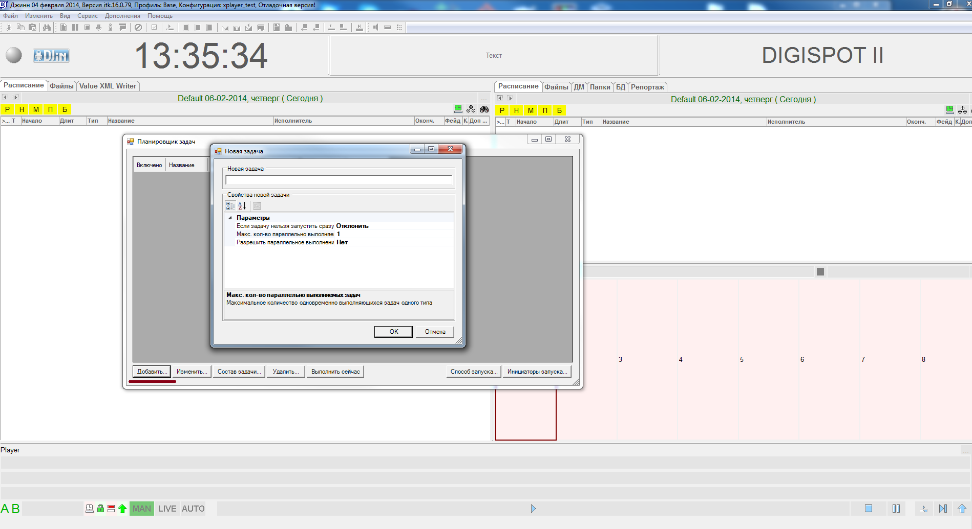
3. Now switch to Task Contents and then add a Step to the task. The relevant step is called Audio signal quality control.
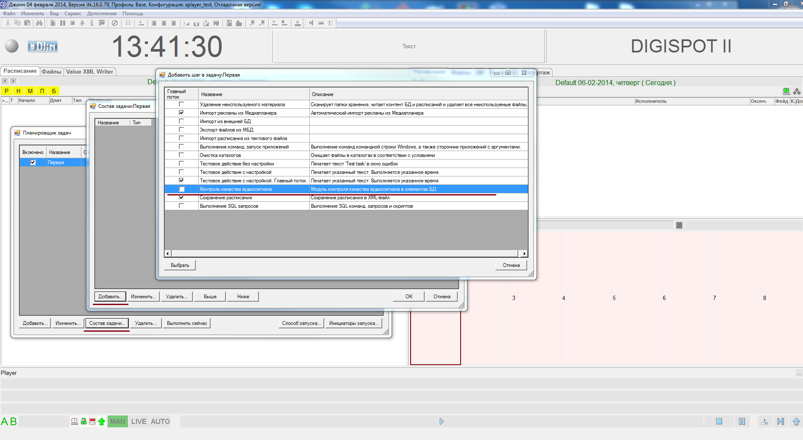
4. Finally, we have reached Audio signal quality control and now we are going to:
- Select a DB category for analysis,
- Specify a set of analyzers for a specific task and configure their parameters.
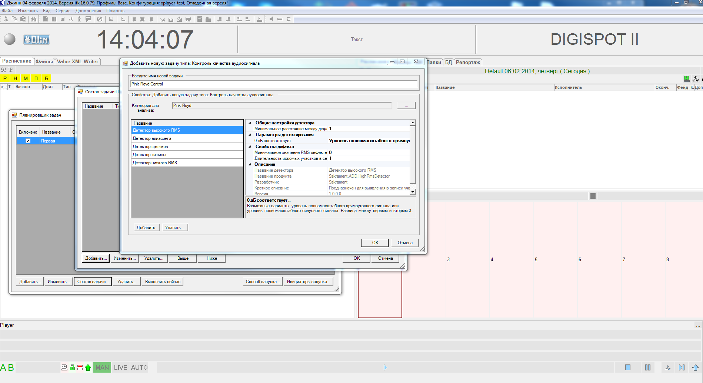
5. The results of the analysis can be seen in DB Object Properties on the Audio Signal Quality tab or the Control Results column of the Schedule tab.
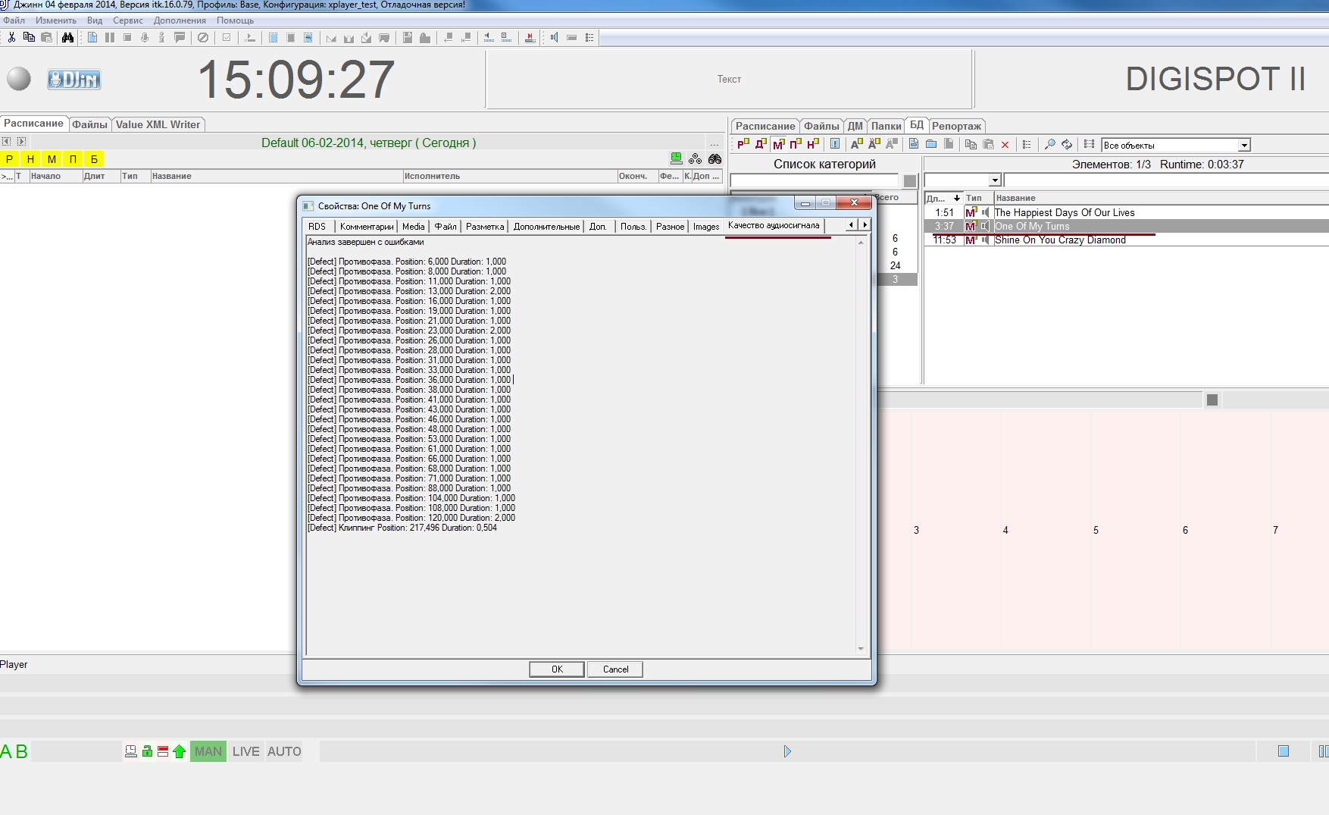
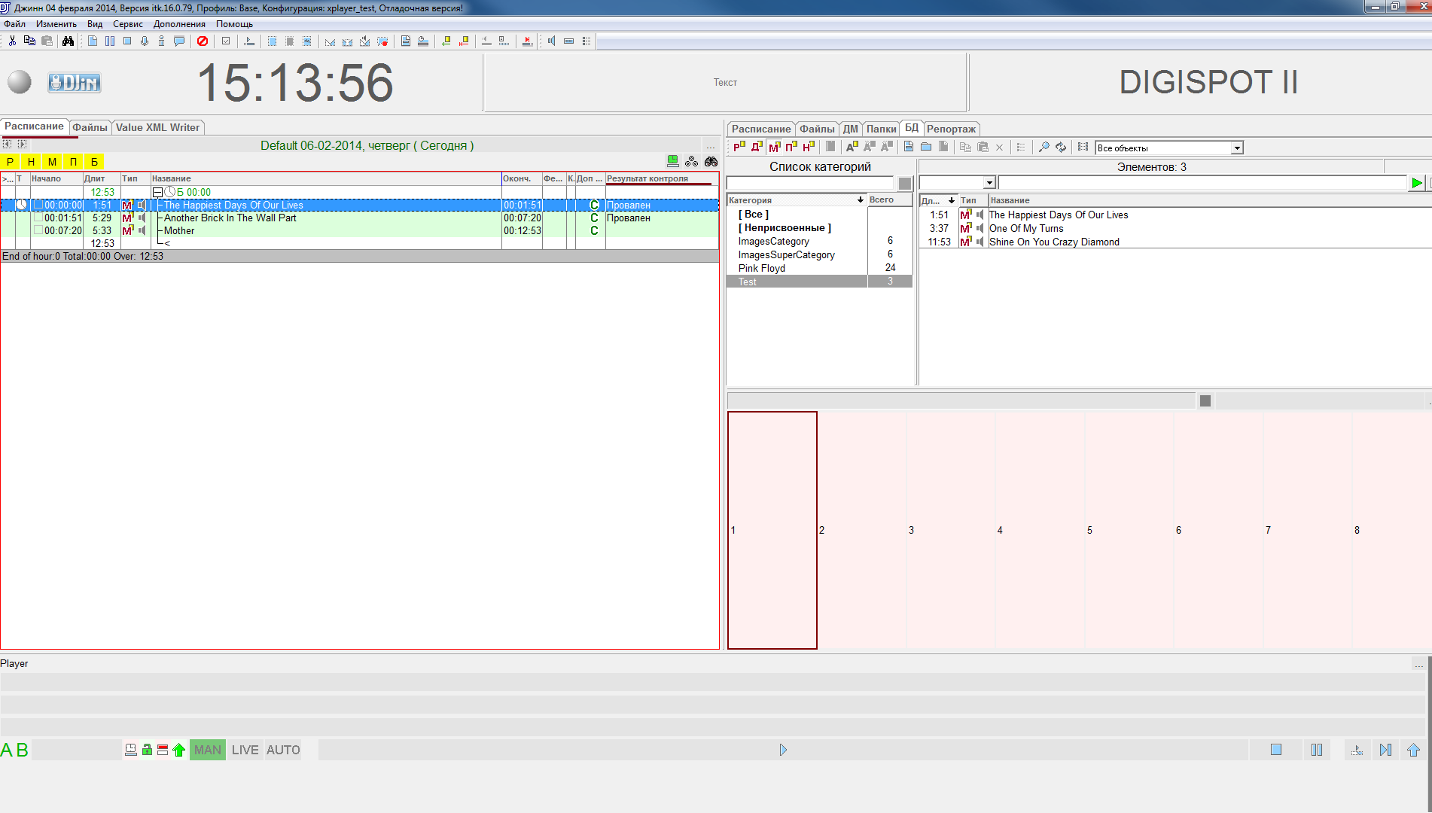

Analyzers
Currently, a set of analyzers developed by SAKRAMENT ITK is available for use, all connectable to Digispot II as plug-ins.
Before running Digispot II, you must copy those builds that have analyzers to Extenders directory, together with all dependencies. Additional information about analyzer parameters can be found in respective analyzer documentation.

Build references
- D3API.dll
- D3APICommon.dll

