Signal Processing
The system allows you to process the signal during playback and re-transmission.
A processor can be built in the playback path, which will process the signal in real time. The main purpose of signal processing is preparation of audio for delivery to an FM processor.
A dynamic switching between processing presets is possible without interrupting the audio stream.
The switching can be done both manually and automatically, depending on the material that is being played.
The following processing points exist at the moment:
- At the output of any ASIO device. This list includes ASIO emulation devices, webcast devices and PtP devices. The processor is activated at the output of the device, which means that in case of re-transmission, both own program and re-transmitted material will be processed.
Terminology:
- Processing point – the point in playback chain where the audio can be processed.
- Processor – A module allowing for the audio stream to be processed
- Playback context – the items currently being played back by the player
- Processing preset – A chain of processors with all of their built-in settings.

Processing Control Unit.
Processing Control window van be accessed from the application’s main menu Service\Equipment\Processing
The window includes the following possibilities:
- Set processor for a processing point.
- Configure automatic preset switching logic
- Manual switching between processing presets
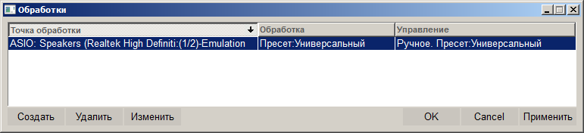

Processing Settings window.
In this window you can switch on or switch off processing, set default preset and configure automatic switching logic.
Automatic preset switching can depend on the following parameters.
- Re-transmission
- Block type
- Properties of currently played item.
Automatic switching conditions are created in the form of an ordered list. The conditions in the list are checked in the order of their location. In case of a match of a condition, the processing switches to a preset which is tied to that condition. If none of the conditions are satisfied, the processing switches to default preset.
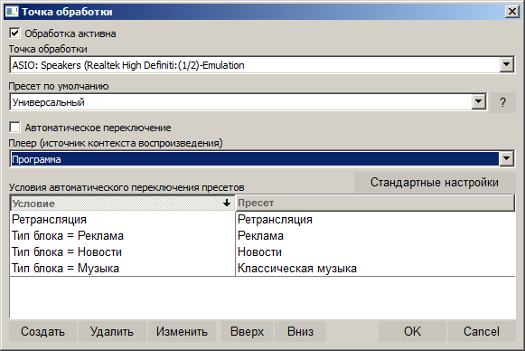

Processing Status Display Module.
Processing Status Display Module allows you to monitor signal parameters at the processing point before and after processing.
The following parameters are displayed
- Level meters.
  - Peak (Peak, TruePeak)
  - Volume indicator (I, M, S, LRA)
- Volume change graph. It switches between displaying one of the parameters - I, M or S. Pre-processing value is indicated in blue, post-processing value – in green. You can select displayed value by using the switch [M,S,I].
The module is created in the vid config file. To create the module, use the following command:
CREATE_OBJ_FILTER_MONITOR OBJID_FILTER_MONITOR
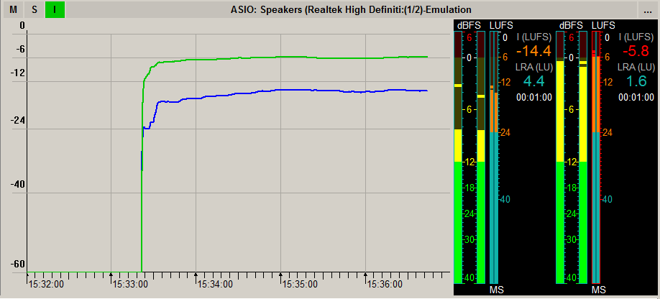
Signal status display module configuration.
To access module configuration window, press the "..." settings button.
Here you can select a processing point, which will have its status displayed.
Configuring volume indicators.
You can access the volume indicators configuration window by right-clicking on the indicator window (similar to all other indicators in the system).
You can find more details about indicator configuration here: Level_meter

Processing configuration
The following procedure is used for configuring a processor.
- Define the output to which processing will be attached. Currently the output must be an output of an ASIO device (see above). Make sure that all players and re-transmission channels are configured to use this output.
- Make sure there is no other type of playback using this physical output (for example, via a WAVE or SP-WAVE device). This is because processing means an increase in volume, so if you mix in another signal to the results of processing, the signal may get clipped while being mixed in the device’s driver.
- Create processing in Processing Control Unit
- Then, in the Processing Configuration window
  - Specify default preset
  - Configure automatic preset switching logic.
  - Activate processing.

Debug logs
All information about basic events of a processing cycle is saved in the log.
Creation of processing:
000047FC @ 02-02-2016, 17:58:17.056 @ @ MEDIA_IO @ MediaFilter @ 395 : CreateFilter, Id=Extern.Proc.1DE5D7F462C1D1A4, Type=1, Preset=
res=ok @ MediaFilterCenter
Loading processing preset:
000047FC @ 02-02-2016, 17:58:17.068 @ @ MEDIA_IO @ MediaFilter @ 12 : LoadFilterPreset, Id=Extern.Proc.1DE5D7F462C1D1A4, Type=1, Preset=crystal_sound_fm
res=ok @ MediaFilterCenter
Assigning processing to a processing point:
000047FC @ 02-02-2016, 17:58:17.069 @ @ MEDIA_IO @ MediaFilter @ FilterSelected, point_id=ASIO: Speakers (Realtek High Definiti:(1/2)-Emulation, new_preset_id=crystal_sound_fm, old_preset_id=commercial_fm @ MediaFilterCenter
Activating processing in a processing point:
000021A4 @ 02-02-2016, 17:58:17.266 @ @ MEDIA_IO @ MediaFilter @ FilterActivated, point_id=ASIO: Speakers (Realtek High Definiti:(1/2)-Emulation, preset_id=crystal_sound_fm, reason=NextFilterDelay complete @ ASIO_DRIVER_EMU
Unloading the processing:
000047FC @ 02-02-2016, 17:58:17.277 @ @ MEDIA_IO @ MediaFilter @ UnloadFilter, Выгружен фильтр обработки, 08EADEA8 @ MediaFilterCenter
All events, bar activation (FilterActivated), can be long-running and are performed in a separate stream called MediaFilterCenter.
Upon completion of processing, the statistics on operating time and processing performance are written to the log:
000047FC @ 02-02-2016, 17:58:17.277 @ @ MEDIA_IO @ MediaFilter @ this=8d10208h stream_dur=71.888 sec, proc_dur=12.767 sec, rtimes=5.631, avg_s

