Level meter.

Function
The Level Meter is designed for:
- Displaying audio level (Peak, True peak)
- Displaying RMS
- Displaying the instantaneous value of the audio volume (M,S)
- Displaying the integral audio volume (I, LRA)
- Displaying the correlation level.
- Audio level adjustment
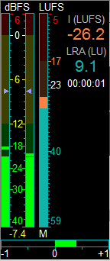

General settings of the indicator
Part of the indicator settings is edited centrally for the whole complex.
These settings can be found in Global Settings: Service\Global settings\More\Audio\Level Meter
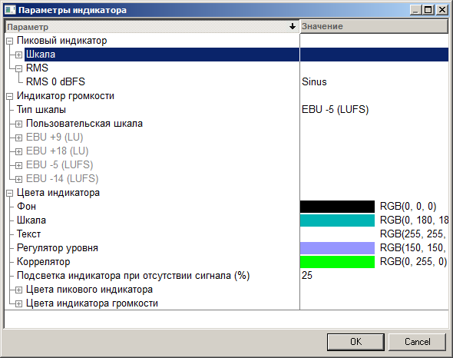
General settings of the indicator include the following parameters
- Default scale for peak indicator
- The level of zero when calculating RMS (Square or Sinus)
- Volume indicator scale
- All colors used in indicators

Configuring the indicator
The configuration window for a specific indicator can be accessed by right-clicking on it.
If an indicator is used for adjusting the level, you should right-click outside the peak level area that has level controllers built into it.
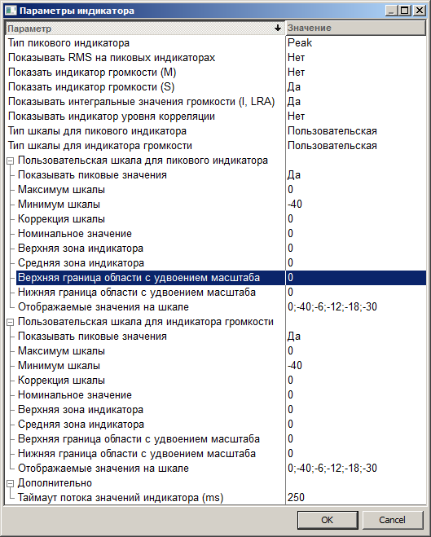
Using the indicator configuration window, you can select which parameters should be displayed in this specific indicator.
You can select the type of peak indicators (Peak or True peak). However, it is not possible to switch the peak indicators off.
Displaying all other parameters can be switched on and off.
Besides that, it is possible to set the parameters of the peak indicator scale and of the level meter different from those set in Global Settings.

Parameters of the indicator scale:
- Show peak levels
- Max scale – the upper limit of the scale
- Min scale – the lower limit of the scale
- Scale correction – Level shift when being displayed by the indicator. This value is added to the level when displayed.
- Upper, middle and lower zones – levels, according to which the indicator is broken into color zones
- Upper and lower limit of the area with double scale – the area in which the displaying scale doubles
- Displayed values on scale – A list of levels divided by semicolons. Here, numeric values that will be displayed on the indicator scale are shown. The order of values becomes important if it is impossible to display all numeric values from the list with an indicator of low height. Values from the beginning of the list have a higher priority.

Audio level adjustment (amplification)
In some modules that use the level meter there is a possibility to adjust the level.
In this case
- There are marks corresponding to current amplification level on peak indicator columns
- Current amplification if dB is displayed under the peak indicator
The amplification is controlled as follows
- By left-clicking on any area of the peak indicator, the mouse cursor moves to current position of the level controller. After that, the position of the controller changes according to mouse movements.
- By right-clicking on any area of the peak indicator, the position of the controller moves to current position of the cursor. After that, the position of the controller changes according to mouse movements.
If separate level adjustment per channel is enabled (for example, in an audio editor), the left and right channel controllers can be moved independently.
To jointly move the controllers press down and hold the left mouse key over the area between the columns of the indicator. This will move both controllers, but retaining their relative shift.

